FIRE SALE OPPORTUNITY – DO NOT MISS THIS!!
TO: All ASI Financial advisors and brokers
From: Jack Dewald, CLU, RHU – President – Agency Services, Inc.
RE: LIFE INSURANCE RATES TO RISE MATERIALLY!
As you have no doubt heard and perhaps read, the adoption of AG38 (Actuarial Guideline 38) by the NAIC (National Association of Insurance Commissioners) is set to have a PROFOUND and SIGNIFICANT impact on the price of Guaranteed Death Benefit UL prices, beginning 1/1/2013.
In addition, the period of extended low interest rates (and well accepted predictions for further periods of low rates) are causing many carriers to review pricing of their entire product portfolio.
Many industry experts predict between 20%-30% increases in price as of 1/1/13. Many of our carriers have ALREADY reduced their product offerings, and several have withdrawn certain products from sale.
Here are a few suggestions:
- If you have any prospects (or suspects) who have been putting off the purchase of life insurance, now is the time to circle back and notify them of looming price increases.
- If you have any in force term insurance policyholders, contact them SOON – many were originally “price-conscious buyers” and the opportunity to CONVERT to a product BEFORE it goes up in price may be of substantial value to these clients. We can help you determine expiration of conversion periods and provide you with a conversion proposal.
- Use this time of uncertainty to reassure your clients you are looking out for their best interest. Contact existing clients and tell them this news –they may want to buy more NOW.
- Sometimes you know of “orphan” policyholders – those that have a policy in force that they have told you about, but that was sold by another agent who is retired or no longer in the business. Circle back to those folks and offer your assistance of a policy review. We can help.
- If you are on Facebook or write a blog, use your “circle of influence” to reach out and offer this news to folks who might not otherwise hear about it.
- Regardless of who wins the election, many people will review their financial and planning goals. Take advantage of this opportunity!
CLICK HERE for an up-to-date summary of each of our carrier’s actions related to AG38, or call our office for help with a case.
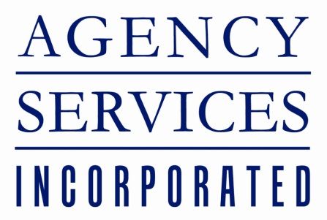

8275 Tournament Drive Suite 350

Memphis, TN 38125

(901) 767-4271

(800) 777-0988
www.agencyservices.com

