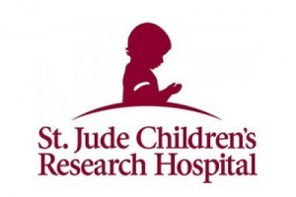
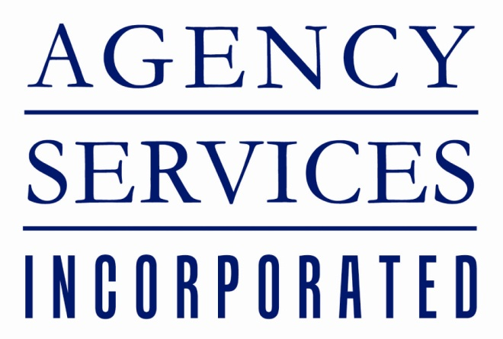

Agency Services, Inc. recently made a $540 donation to St. Jude Children's Research Hospital!
At our Open House on June 8th, we raised $270 for chances to win a Scotty Cameron Titleist putter. ASI matched the amount, making the total amount of the donation $540!
Thanks to all our guests who participated in the raffle and made this donation to St. Jude possible.

